Circuit Analysis Lab 5 - Proteus
Name: Noor Fatima
Registration No: 2025CE77
Objective: To understand how to use Proteus for circuit simulation and verify outputs.
Task 1:
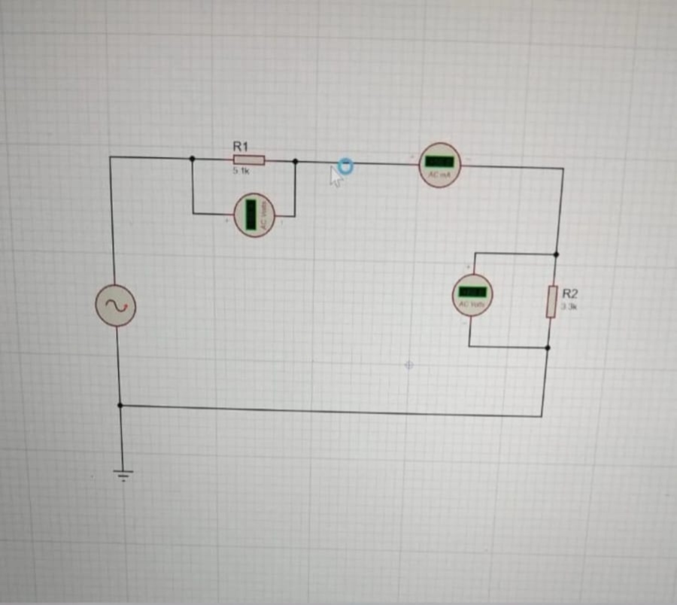
Measure current between R1 and R2 and voltage across R1 and R2.
Simulated Values:
R1 Voltage = 5V
R2 Voltage = 3V
Current = 0.02 A
Task 2:
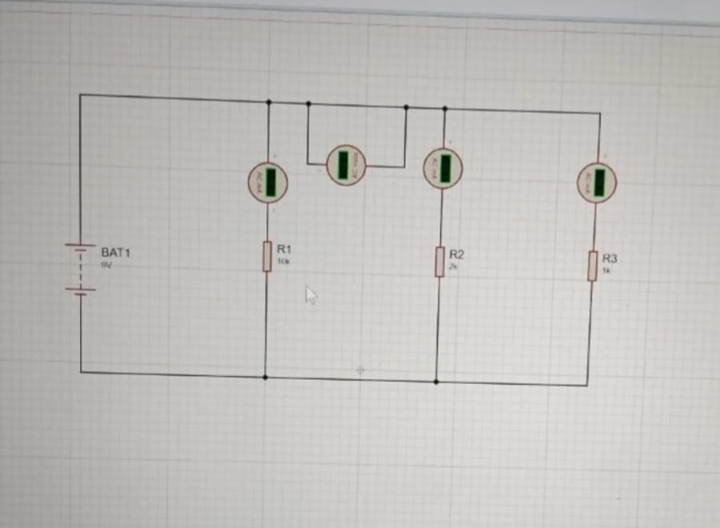
Measure current across R1, R2, R3 and voltage between node 2 and 3.
Simulated Values:
R1 Current = 0.01 A
R2 Current = 0.015 A
R3 Current = 0.02 A
Voltage (Node 2-3) = 2V

